**Start VS Code as an administrator.**

**Commands needed for initial setup for twilio serverless**

**03/01/2021 we need to upgrade to Node V12**

<https://www.twilio.com/docs/runtime/twilio-functions-node-v12-upgrade>

**Installing the Twilio CLI**

**npm install twilio-cli -g**

**Authenticate the Twilio CLI or set variable globally in system environment.**

**twilio login**

**npm i -g serverless (run this from cmd prompt as Adminstrator, is running from VS code terminal gives a problem)**

**command for install serverless**

**twilio plugins:install @twilio-labs/plugin-serverless**

**New Installation Code for Node version 12** **// 03/01/2021**

**twilio plugins:install @twilio-labs/plugin-serverless@latest**

**If existing twilio plugin than need to remove first**

**twilio plugins:remove @twilio-labs/plugin-serverless**

**Install the Dabble Lab Autopilot Plugin**

**twilio plugins:install @dabblelab/plugin-autopilot**

Note: If there is error related to remote sign run below command from terminal and vs code should be open as administrator

**Set-ExecutionPolicy -ExecutionPolicy RemoteSigned -Scope LocalMachine**

After running above command then run again

**twilio plugins:install @dabblelab/plugin-autopilot**

**command for Start the local development environment**

**twilio serverless:start**

**OR**

**Npx twilio-run**

**Commands needed to deploy and update services and serverless functions**

**Command for deploy serverless service and functions(explain service name and url)**

**twilio serverless:deploy**

**New deployment Code for Node version 12** **// 03/01/2021**

**twilio serverless:deploy --override-existing-project --runtime=node12**

**if it does not deploy then remove data in the .twilio-function file and then deploy again.**

**Command for update services and serverless functions**

**twilio serverless:deploy –-force**

**Identify for services the place or file where we change the service name**

We can change the service name inside the package.json file and also we need to remove everything from .twilio-function file.

Then we need to run the deploy command below.

**twilio serverless:deploy**

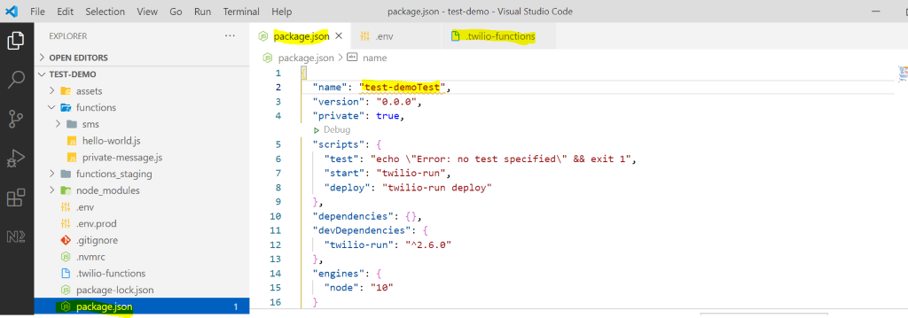

**Commands needed to upload and export in model folder for schema.json**

https://github.com/dabblelab/twilio-cli-autopilot-plugin

**Command for  Export bot schema from twilio cloud to vs code**

**twilio autopilot:export --unique-name InitialTwilioDir_Bot**

**Command for Deploy schema.json from vs code to twilio Cloud. Model is the name of the folder where we have the schema.json file.** This will only be used for deploying to Staging and production (MainIVR) sub-accounts from GitHub. Remember to copy schema.json as staging.json and production.json files and change the urls in each file.

**twilio autopilot:deploy -t model**

**to update the autopilot**

**twilio autopilot:update --schema <staging.json> --unique-name <dev-mark>**

**twilio autopilot:update --schema <production.json> --unique-name <dev-mark>**

**Identify for autopilot the place or file we change the unique name and friendly name**

There is a file with name schema.json in the model folder.  In this file we can change Friendly Name and unique name property like below screen shot.

And then just run the below command for update the unique name and friendly name

**twilio autopilot:deploy -t model**

